**Title: Guardian of the Outlands**

**Genre:** top-down 2D shoot ‘em up

**Target audience:** 12+ years old

**Platform:** PC (web)

**Intended rating:** PEGI 12 (violence)

**Concept**

The player must defend a collection of barrels in the centre of the screen from waves of enemies coming in from the edges of the screen. The enemies will try to get to the barrels, pick one up, and escape with it by exiting the screen at a random location. The player can move their tank and fire its weapon to kill the enemies before they can steal all of the barrels. Points are earned by shooting enemies and for every barrel left at the end of each wave. Power-ups and hazards will randomly spawn that will help or hinder the player. The game ends when all of the barrels have been stolen by the enemies.

**Game Summary**

As the only guard stationed at a military base on a long-forgotten planet, you are charged with maintaining a foothold in the area. Armed only with your heavy tank, you must defend your stockpile of fuel and supplies from the hostile, indigenous people. They will try their utmost to steal your precious supplies and overrun the base. How long will you survive?

**Play Mechanics**

* Score points by shooting enemies and for every barrel left at the end of each wave
* Pick-ups (invincibility, points multipliers, increased damage)
* Hazards (oil spills, tar patches)
* High scores

**Unique Selling Points**

* Smart AI - reacts to its surroundings and changes its movement target/behaviour dynamically
* Player vs entropy - the stockpile becoming more spread out over time increases the difficulty
* Difficulty curve to keep the player’s interest – random combinations of enemies will spawn in each wave

**Competitors:** Rip-Off [1]

**Guardian of the Outlands**

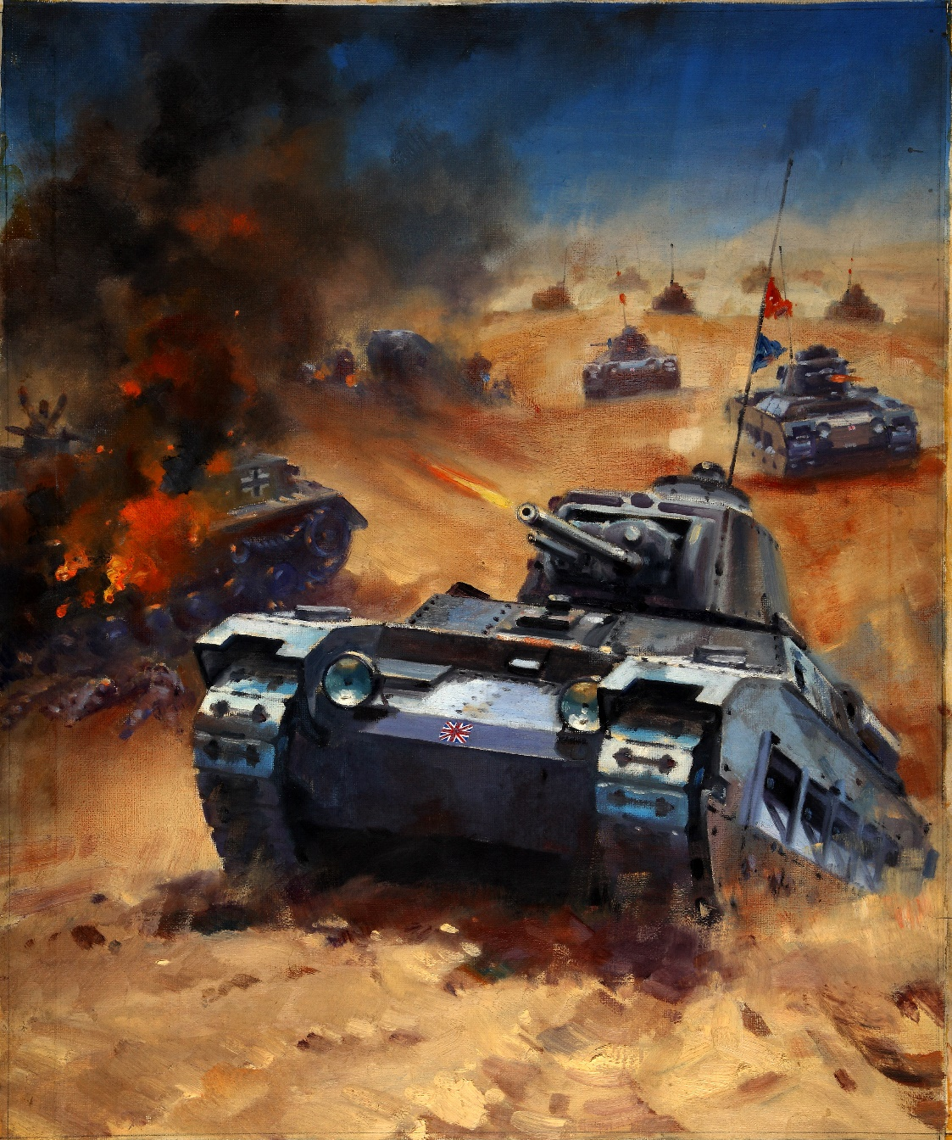

**Designed by Tom Roberts**

**15th March 2015**

**For PC (web)**

**Ages: 12+**

**Finish date: 28th May 2015**

**Detailed Design**

**Game Outline**

The player will spawn at a random location on the screen. Each enemy will spawn at a location on the edge of the screen that is chosen randomly at the start of each wave.

Difficulty will vary randomly over successive waves by spawning random numbers and random types of enemies, such as quick-moving jeeps that can pick up a barrel and escape quickly, and slow, tough tanks that take more bullets to kill.

Players score points by killing an enemy (each type of enemy gives a different score) and earn points for each item remaining on the screen at the end of a wave. If they crash into an enemy, they will lose points and be respawned at a random position. The game ends when all of the barrels have been stolen. The player’s final result is their cumulative total of points, the number of waves they survived, and the time taken.

The player can collect power-ups that give bonuses including: increased damage, invulnerability, double points. Hazards may also appear that will hinder the player, such as oil spills that change the player’s direction randomly, patches of tar that slow movement etc.

**Software**

The game will be created using Unity 5 as it is often used to develop games for websites (played via the Unity Web Player browser plugin), but it also provides ways to easily deploy to other platforms if needed[2]. It is one of the most established game creation systems[3] and therefore has a plethora of documentation, and official and community-contributed tutorials[4].

Unity also offers many libraries and functionality that the game will need (basic physics, collision detection, input handling).

**Hardware**

The game will be developed for the PC as this would be the main platform where people play games on the web. The hardware requirements of the game will be kept minimal and will not need high-end components to run, leaving the possibility of deploying to mobile platforms in the future open.

Targeting the PC also allows the use of the keyboard and mouse as game controls for the player to move their tank and fire its weapon, something which may be more difficult to do using touch/accelerometer controls on mobile phones.

**Graphics**

2D sprites and vector graphics will be used for all of the art as it is a top-down 2D game, so does not require 3D models. There will be sprites for the player, enemies, barrels, pick-ups, hazards, the menu system, bullets, explosions etc. A custom font will be used for text elements of the game (menus, score indicator etc), and it will also be sourced from websites that offer licensed art.

All of the art will be sourced from websites that offer art that are in the public domain (so have no limitations on use), or have been released under a Creative Commons license. Credit to the creators will be given in a README text file or credits section of the game in the manner that the license stipulates.

***Examples of the graphics and fonts intended to be used can be seen in Appendix 1.***

**Audio**

**Music**

The main menu of the game will have looping background music sourced from websites that offer Creative Commons and Public Domain-licensed music. The track chosen will need to be upbeat enough to convey the action style of the game but considering that it could be looped many times if a user is browsing the menu, it should not be too overbearing.

During gameplay, there will also be looping background music that is upbeat and will be used to create tension and action whilst playing.

**Sound effects**

There will be no sound effects in the main menu as I feel that sounds played when hovering or clicking a button, or transitioning between menu screens, would become quite annoying after a while; feedback on these events are instead given visually (buttons changing colour, having a click animation etc).

During gameplay, there will be sound effects for the player firing their weapon, vehicles exploding, and a barrel being stolen off the edge of the screen (accompanied by visual feedback). An engine sound effect for the player and enemies moving may be used, if it is not too annoying to have the same effect being triggered frequently (this will be determined during gameplay testing).

All audio will be sourced from websites that offer work released into the Public Domain or under a Creative Commons license, and credit to the authors will be given, as stipulated in the license.

**Code Structure**

**Factory Design Pattern**

This creational pattern will facilitate the creation of objects. There will be factories that will create vehicles (player, enemies), barrels, pick-ups (power-ups, hazards) etc. A ‘manager’ class running in the game loop will be responsible for monitoring the game’s state and triggering the correct factory to instantiate the required objects, as needed.

*See ‘****Gameplay Structure Diagram’*** *on page 5, and ‘****Factory Activity Diagrams’*** *on page 7.*

**Object Pooling Pattern**

This pattern is best suited for games that require a lot of instantiating and destroying objects, or repeating some other expensive memory operation. As this is a shooter game, object pooling will be used for bullets. Any game entity that needs to use bullets (such as the player) will check objects in and out of a pool rather than repeatedly doing costly memory allocations to create/destroy bullet objects.

*See ‘****Gameplay Structure Diagram’*** *on page 5, and ‘****Player Bullet Pool Activity Diagram’*** *on page 8.*

**MVC**

To adhere to MVC, an object’s animation and movement (view) will be kept separate from the variables that represent its internal state (model). This will be done by splitting object controllers into several scripts that reference each other i.e. an enemy colliding with a barrel will be detected in the view, which will trigger a change in its state in the model. Furthermore, the view may be split into more scripts to keep it as modular as possible (player movement, player shooting, player death etc). See ‘**Gameplay Structure Diagram’** on page 5.

**Code Structure/Activity Diagrams**

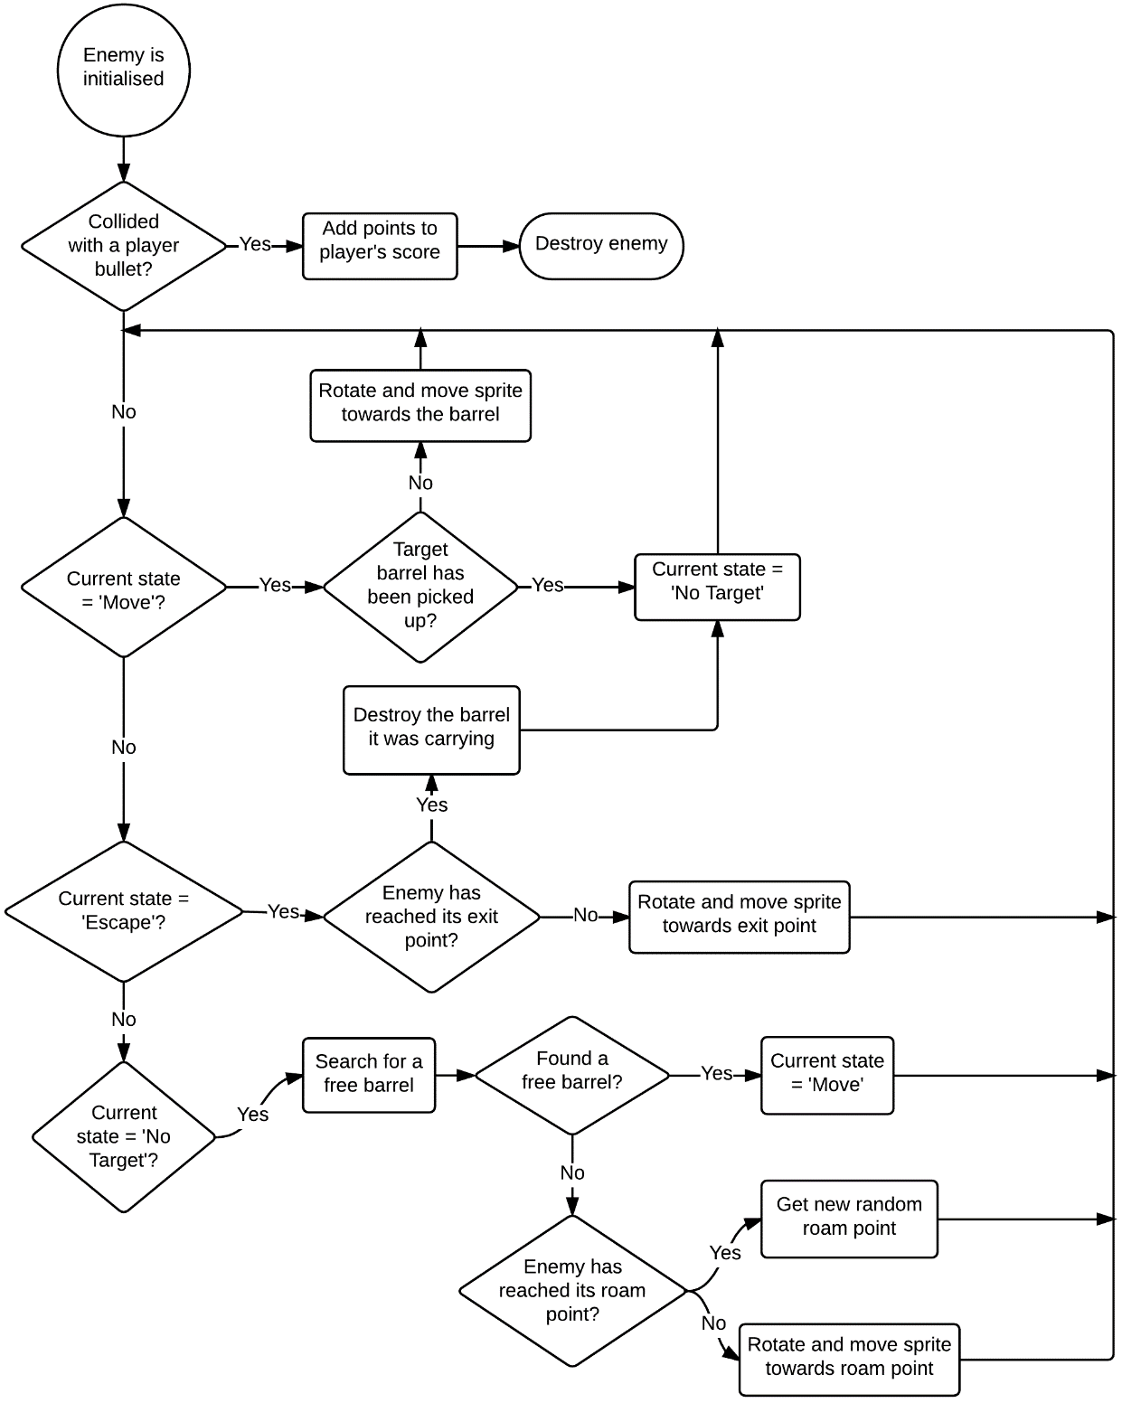**Enemy Activity Diagram**

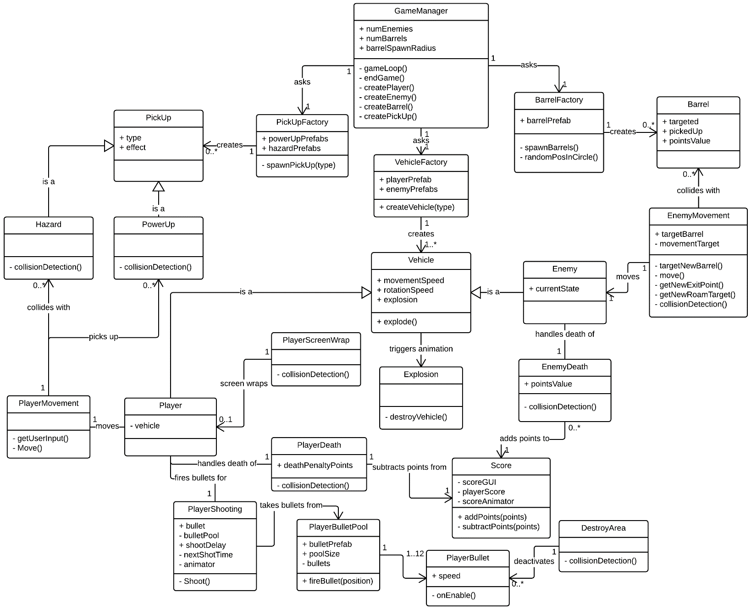**Gameplay Structure Diagram**

|  |  |
| --- | --- |
| **Menu Structure Diagram** | **Player Activity Diagram** |
|  |  |

|  |  |
| --- | --- |
| **Enemy Factory Activity Diagram** | **Player Factory Activity Diagram** |
|  |  |

**Player Bullet Pool Activity Diagram**

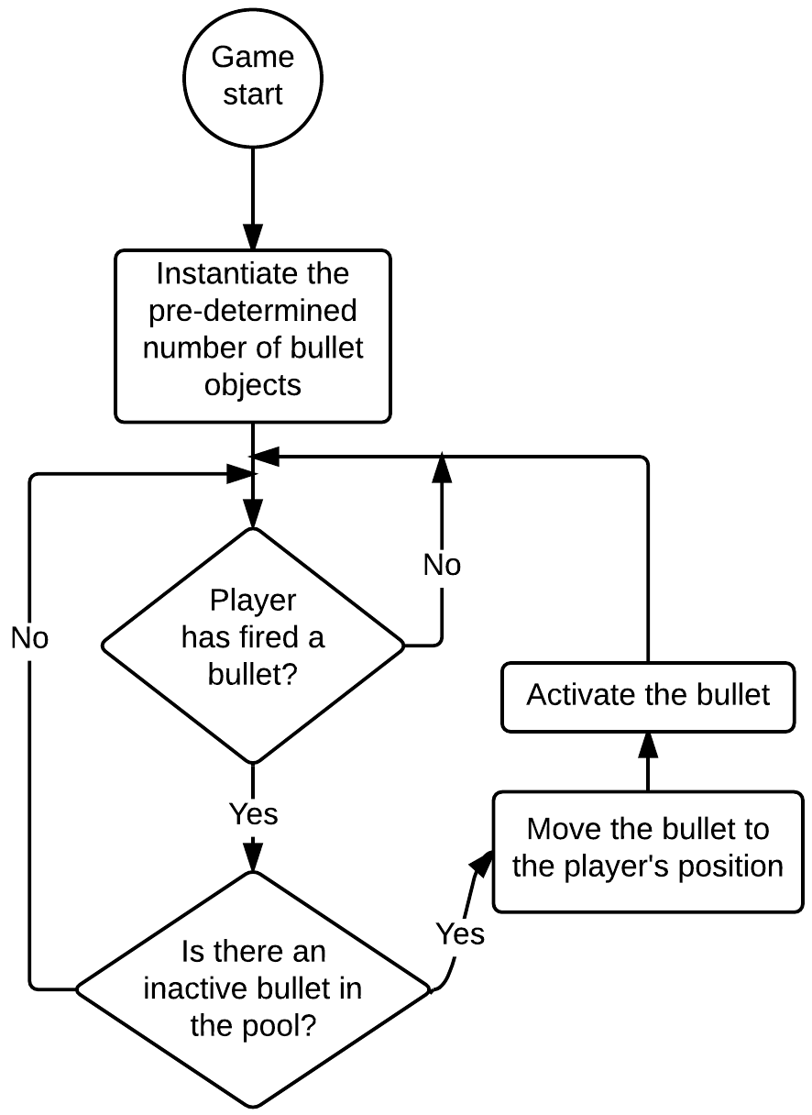

**Game-Specific Features**

**Collision Detection**

Collision detection is the basis of most of the gameplay. The player is able to shoot bullets that collide with enemies to destroy them. If the player collides with an enemy, the player will be destroyed and respawned at a random position on the screen. Collision detection is also used to implement an enemy picking up a barrel by bumping into it.

Around the edge of the game screen, there is an invisible collider that will destroy any objects (except the player) that exits the screen. This is to prevent memory leaks caused by objects moving out of the field of view but not being destroyed (i.e. stray bullets).

**Artificial Intelligence**

Artificial intelligence controls the enemies to make them intelligently react to their surroundings and change their target and behaviour dynamically[5]. They have three modes: No Target, Move, and Escape.

The ‘No Target’ state means that there are no free barrels for the enemy to move towards and try to pick up. This usually happens when there are more enemies than barrels on screen due to some having already been stolen. The enemy will roam randomly around the screen whilst repeatedly scanning the game scene for a barrel that no other enemy is already moving towards. The enemies are intelligent enough to know that if they accidentally bump into a barrel whilst roaming, they will pick it up and switch to ‘Escape’ mode.

The ‘Move’ state is used for when the enemy has a barrel targeted and can move towards it. The enemies are intelligent enough to know that if they accidentally bump into a barrel that wasn’t their intended target, they will abandon their original target and pick up this new barrel and switch to ‘Escape’ mode.

The ‘Escape’ state means that the enemy has picked up a barrel and must try to escape to its randomly designated exit point somewhere on the edge of the screen. An enemy can only carry one barrel at a time so if it bumps into any other barrel whilst trying to escape, it will simply ignore it.

**Physics Engine**

The physics engine is used to move bullets across the screen at an arbitrary speed.

**Time Management Plan**

**Tasks implemented during prototyping/early development:**

|  |  |  |  |  |  |
| --- | --- | --- | --- | --- | --- |
|  | **Monday 16th March** | **Tuesday 17th March** | **Wednesday 18th March** | **Thursday 19th March** | **Friday 20th March** |
| **AM** | Source sprites for: player, enemies | Player movement | Player shooting + animations | Preliminary enemy AI – Move mode (picking up barrels) | Preliminary enemy AI – No Target mode |
| **PM** | Source sprites for: bullets, explosions | Player screen wrap | Collision detection + destroy enemies |

|  |  |  |  |  |  |
| --- | --- | --- | --- | --- | --- |
|  | **Monday 23rd March** | **Tuesday 24th March** | **Wednesday 25th March** | **Thursday 26th March** | **Friday 27th March** |
| **Tasks** | Preliminary enemy AI – No Target mode | Preliminary enemy AI – Escape mode | Source sprites for new ‘Jeep’ enemy type | Create + fill Object Pool of bullets | Scoring system – shooting enemies |
| Integrate new enemy into game | ‘Fire’ bullets from the pool | Scoring system – points for barrels left on screen |

|  |  |  |
| --- | --- | --- |
|  | **Monday 30th March** | **Tuesday 31st March** |
| **AM** | Main menu layout + animations | Main menu functionality |
| **PM** | Instructions menu layout + animations | Instructions menu functionality |

**Tasks to be completed:**

|  |  |  |  |  |  |
| --- | --- | --- | --- | --- | --- |
|  | **Monday 11th May** | **Tuesday 12th May** | **Wednesday 13th May** | **Thursday 14th May** | **Friday 15th May** |
| **AM** | Refactor for MVC – player, enemy | Refactor for Factory pattern – Game Manager | Refactor vehicles for Factory pattern | End game screen layout – sprites, animations | Spawn pick-ups |
| **PM** | Refactor barrels & pick-ups for Factory pattern | End game screen – score, waves survived, time | Pick-ups effects on the player |

|  |  |  |  |  |  |
| --- | --- | --- | --- | --- | --- |
|  | **Monday 18th May** | **Tuesday 19th May** | **Wednesday 20th May** | **Thursday 21st May** | **Friday 22nd May** |
| **AM** | Hazards - spawning | Enemy hit points – modify enemies | Source sprites for new ‘Heavy’ enemy type | Change enemy ‘No Target’ mode to Pac-Man-style player chasing | Change enemy ‘No Target’ mode to Pac-Man-style player chasing |
| **PM** | Hazards – effects on the player | Enemy hit points – modify player | Integrate new enemy into game |

|  |  |  |  |  |
| --- | --- | --- | --- | --- |
|  | **Monday 25th May** | **Tuesday 26th May** | **Wednesday 27th May** | **Thursday 28th May (deadline)** |
| **AM** | Main menu music | High scores | Last code testing (bugs/exceptions) | Verify final build runs + submit |
| **PM** | Gameplay music + sound effects | Last gameplay testing (tweaks to make it fun) |

**Appendices**

**Appendix 1**

|  |  |
| --- | --- |
| **Vehicles[6]** | |
| **Player** | **Enemies** |
|  |  |

|  |  |
| --- | --- |
| **Projectiles[7]** | |
| **Bullets** | **Explosions** |
|  |  |

|  |  |  |
| --- | --- | --- |
| **Barrel[8]** | **Power-ups** | |
|  | (set to different colours to indicate which power-up it is) | |
| [9] | [10] |

|  |  |
| --- | --- |
| **Hazards** | **Menus** |
|  | [11] |

|  |
| --- |
| **Font[12]** |
| True Crimes Font Specimen |

**References**

1. The International Arcade Museum. (2015). Rip Off. Available: http://www.arcade-museum.com/R/Rip_Off.html. Last accessed 15th Mar 2015.
2. Unity Technologies. (2015). Multiplatform. Available: http://unity3d.com/unity/multiplatform. Last accessed 2nd April 2015.
3. Unity Technologies. (2015). Public Relations. Available: http://unity3d.com/public-relations. Last accessed 15th Mar 2015.
4. Unity Technologies. (2015). Learn With Unity. Available: http://unity3d.com/learn. Last accessed 15th Mar 2015.
5. Tim Skelly. (2001). Rip-Off: A Description of Programmed Behavior in a Video Game. Available: http://www.red3d.com/cwr/boids/RipOff_Flocking.html. Last accessed 16th Mar 2015.
6. chabull. (2013). Tanks and Trucks. Available: http://opengameart.org/content/tanks-and-trucks. Last accessed 21st Mar 2015.
7. chabull. (2013). explosions. Available: http://opengameart.org/content/explosions-0. Last accessed 22nd Mar 2015.
8. chabull. (2013). Boxes and Barrels. Available: http://opengameart.org/content/boxes-and-barrels. Last accessed 23rd Mar 2015.
9. sacio. (2014). Simple rotating coin. Available: http://opengameart.org/content/simple-rotating-coin. Last accessed 1st Apr 2015.
10. Écrivain. (2010). Star. Available: http://opengameart.org/content/star. Last accessed 1st Apr 2015.
11. AhNinniah. (2013). Night forest background. Available: http://opengameart.org/content/night-forest-background. Last accessed 29th Mar 2015.
12. Walter Velez. (2009). True Crimes. Available: http://www.fontsquirrel.com/fonts/True-Crimes. Last accessed 28th Mar 2015.